TRI-STATE OLYMPIC TKD SPARRING SEMINAR
When: Saturday, January 27th, 2018 ~ 1:30-3:30pm
Where: Yoo’s Martial Arts, Tarrytown NY 10591
Eligibility: Competitors will be recommended by Masters
Application Deadline: 1/25/18
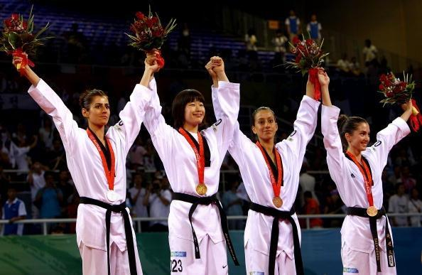
Participating Schools: Elite Taekwondo (Norwood, NJ), White Tiger Taekwondo (Greenwich, CT), Hong Ik Martial Arts (New Rochelle, NY), Yoo’s Martial Arts (Tarrytown, NY and Fairlawn, NJ)

Student Name: |  | Gender: Male Female
Belt Rank: |  | Age:
Emergency Contact Name: |  | Relationship:
Emergency Contact Phone Number : | ( )

Fee | Payment Method
$50.00  No refund, transfer or credit. | Cash Check Credit Card  Make Checks payable to: Yoo’s Martial Arts

Waiver & Release From Liability
By signing and returning this application and waiver it is understood a martial arts contest is physical and there is risk of injury. I/my child understand there is risk of injury and will act responsibly. I release Yoo’s Martial Arts, instructors and employees from any claim resulting from any injury that I/my child may receive while participating in THE TRI-STATE OLYMPIC TKD SPARRING SEMINAR.

Student Name: _______________________________ Date: ____ / ____ / ____
Parent/Guardian Name: _________________________ Signature: _____________________

